Smart Shopping

Planner

Kunal Saxena

Lucas Sherman

Raymond Wang

Brad Schultz

Unicorn Frappuccino

Table of Contents

**Introduction** **2**

Problem Definition 2

Existing Solutions 2

Our Solution 3

**Pre-Design** **4**

Personas 4

Scenarios 5

Use Cases 6

**Evolution** **7**

**Link to the Final Prototype** **10**

**Evaluation** **11**

**Updates and Changes** **14**

**Future Work** **14**

**Lessons Learned** **15**

Struggles Faced 15

Key Decisions 15

Interesting Takeaways 16

**Conclusion** **16**

**Appendix A** **17**

Bob’s Persona 17

**Appendix B** **17**

Original Scenarios 17

**Appendix C** **18**

Low Fidelity Prototype 18

**Appendix D** **23**

Medium Fidelity Prototype 23

**Appendix E** **29**

Survey Results 29

# Introduction

Unicorn Frappuccino was created on May 10 with a single vision in mind: revolutionize people’s shopping experience. After the team members discussed different ideas, it was decided that the project aim would be to design a mobile application that helps shoppers choose which shops to go to. Smart Shopping Planner was born, it’s main concept being to display prices of store items allowing users to compare different stores and choose the best store for themselves. The main idea is that a shopper will want the cheapest possible price for any items, but then the application also lists the store location and how far it is which allows the user to deem if the certain store is too far to travel to save the couple dollars.

## Problem Definition

While researching the problem we aimed to solve, many different sub-problems were noticed and helped us form our precise problem definition. A few of the issues we realized are:

* products may have different prices in different stores
* products may not have a price tag on store shelves
* products may be out of stock

Each of these three problems all contribute to the main problem which is: shoppers are spending more money and more time than necessary when shopping. Now the goal was clear: find a way to solve all three of these issues in a single application.

## Existing Solutions

While researching for already existing barcode scanning applications we came across ShopSavvy which is a mobile application that focuses on providing users with shopping deals. The application also gives users access to multiple stores to look at while searching for deals and the application also uses a search bar, My Scans and Views, and a barcode scanner to help assist users. The application’s use of My Scans and Views is to help users keep track of items the user wishes to keep an eye on in case the item goes on sale. When a user uses the barcode scanner to scan an item, the application will go to the items page on the application or if there is no page then it will say it could not find the product.

## Our Solution

Our application is similar to ShopSavvy but our design was to focus more on store stock quantity and store stock availability instead of deals and savings. Our application doesn’t have a savings and deals page but instead gives users the option to search for products using a search bar or scanning the barcodes of products.

When our application has a product's information, either from search bar or scanning, it will display the stores that sell the item, the price from each store, each store’s current stock quantity, and the distance from the user's current location to the each store. This is the main idea of our application and the way it provides a solution to the main problem. Since the main idea of our application is to save time and money for the users we wanted to be efficient as possible, so we felt that a simplistic design provides a quick and easy method for users and aids in learnability.

Our application has a few different features. One of the features that helps users is that they can sort by nearest store or by lowest price of product. This feature will allow users to see all available stores and determine what is more important to them: lowest price or closest location. The application utilizes the barcode scanner feature to scan products in store when they don’t have any available prices tags; this will allow users to determine the price of an item saving them the time spent in stores. The barcode scanner can also scan the available shelf tag of an product that is out of stock on the shelf; this will allow users to determine if the store is indeed out of stock or to check stock quantity on any other available stores that might carry the same product. A user can also scan a product’s barcode while at home, doing this will allow the user to determine if store has the item currently in stock; saving the user the time instead of going into the store and finding the item is out of stock.

Like ShopSavvy our design uses a history page which is like the ShopSavvy My Scans & Views page. Our history page keeps track of all recent items that the user has viewed. This history feature will allow users to keep information of specific items instead of the redundancy of always searching the item again.

# Pre-Design

Before taking to design our application we did the necessary research to narrow our preferred audience. In doing so, we developed relevant personas to capture the types of users that would be using our application. Additionally, we developed scenarios to represent the situations that some users would be in when using our application. Finally, we developed use cases using all the available functions of our application to represent the main uses of the application.

## Personas

The main personas we developed are as follows in the next 2 paragraphs. We initially had another persona for the user “Bob” which can be seen in Appendix A, however we realized that Bob was too unique and not necessarily a representative user of our application. Additionally, the use case that Bob was following was almost exactly the same as Frank’s use case (seen below) which is searching for items. The removal of Bob’s persona lead to the creation of Kelly’s persona (seen below) in order to leverage another one of our application’s main use cases, which is the history function.

Kelly, 37, lives in Victoria, BC. Kelly works as a secretary to a Dentist's office while her husband works with BC Hydro. Kelly is a mom of 3 kids, ages 3, 5, and 9. Kelly has to do most of the shopping for her family and tends to have to take the kids with her while she goes out to shop. It’s hard for her to shop while keeping track of the kids and making sure that they are behaving themselves, especially since they can’t stay still for long. Kelly has had trouble multiple times going to the store and finding that the product she’s looking for is out of stock, and this annoys the kids as they are dragged around from store to store without their mom even getting anything sometimes.

Frank, 34, lives in Kelowna, BC. Frank is a bargain shopper who loves to get the best deals, especially on high value items. He loves to brag to his friends about the price of the latest tech that he’s bought. He knows his local stores very well and regularly keeps tabs on price fluctuations. Frank could also use online retailers to get even better prices, however he has had his email account login details stolen in the past, so he is now very wary of entering sensitive information on the internet, and will refrain from doing so whenever possible.

## Scenarios

Our original scenarios were very basic outlines of the interaction as seen in Appendix B. We then further developed and made the scenarios specific and precise. We also added a third scenario after making changes to our use cases to reflect the interaction of the application’s secondary use case. They depict the scene without including excess explanations and information. The first scenario is an example of when a shopper encounters an empty shelf, but uses the application to double check if the entire store is actually out of product or not (scanning interface). The second scenario is a shopper in a rush that also is looking for the store with the cheapest price (searching interface). Finally, the third scenario is a user checks stock availability for a previous searched product through the history page (history interface).

Kelly goes to the store to buy Dove brand soap. When she arrives, there is an empty shelf where the product should be. There are no store assistants near, but the price tag and barcode are on the empty shelf. Kelly opens the Smart Shopping Planner application on her smartphone to scan the barcode from the shelf. The application displays all the nearby stores that sell this product and Kelly notices that the current store still has Dove soap in stock. She goes to the help counter to get some assistance in finding the product.

Frank, a bargain shopper, is looking for some AA batteries since he recently ran out. He wants to get them at the lowest possible price quickly, since he needs them soon. He abandons the idea of searching through multiple flyers and comparing prices, and instead he opens the Smart Shopping Planner application on his smartphone. He then searches for “AA batteries” on the application using the search tool. He chooses Duracell brand batteries, since it’s a brand he knows, and finds that a 4 pack of AA Duracell batteries is on sale at his local Walmart, with the lowest price overall at the moment. Frank begins to go to Walmart after he checks that the batteries are in stock.

One of Kelly’s children has a birthday coming up, and Kelly would like to buy a Nintendo Switch as a birthday gift for her kid. Kelly searched “Nintendo Switch” through the Smart Shopping Planner application and it is out of stock everywhere. The next day, she tried to check the stock availability again by opening the Smart Shopping Planner application and went to the history page, selecting the Nintendo Switch entry which she searched yesterday. It displays all the stores that sell this product but all of them are still out of stock. Kelly keeps track of it everyday by repeating the same method through Smart Shopping Planner application. Finally, five days later, Kelly found that it’s back in stock at Gamestop. Kelly goes to the store and buys a Nintendo Switch for her kid.

## Use Cases

We developed a list of actions that can be done in the application and then built use cases up from doing a certain sequence of steps. Our finalized list of actions ended up being:

1. The shopper opens the “Smart Shopping Planner” application
2. The shopper taps the “Scan Barcode” button
3. The shopper enters what they are shopping for in the search box and taps the magnifying glass
4. The shopper holds their phone steady and aims the camera at the product barcode
5. The shopper selects their preferred product by tapping
6. The shopper selects their preferred store by tapping
7. The shopper taps the “History” button

There is only one main use case of the application and the second use case is significantly less used. The main use case is for people searching or scanning an item to view the store results and selecting which store they want. The secondary use case is for when someone has previously searched or scanned an item and they want to do the same search, but to save time they can access their previous searches under “History”. The two cases are completed by following these two flowcharts:

Primary Use Case Secondary Use Case

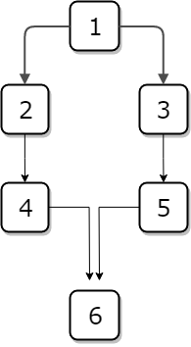

# Evolution

The evolution of our design throughout our three prototypes was fairly minimal. Starting from our low fidelity design, we had all the main concepts and screens exactly how we wanted. Changes made were generally small things to increase aesthetic pleasure. Some of the few changes are listed below:

* added shading to navigation bar when on home/history/settings screens
* added shading to “Nearest” and “Lowest Price” when selected
* displaying in or out of stock when listing stores
* removed customer reviews, and website listing when display store information

The low, medium, and high fidelity screens which highlight the evolution of the design for the search use case are shown throughout the following pages.

▼ Home Page

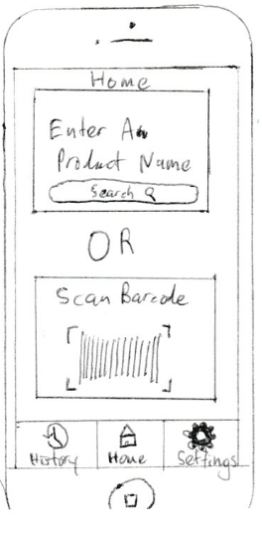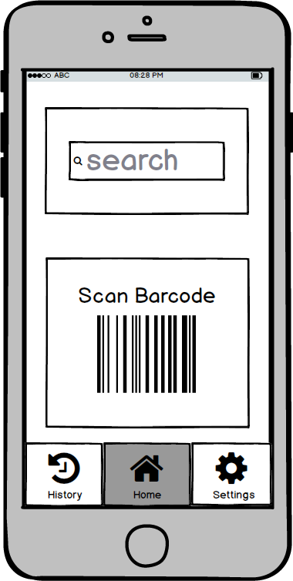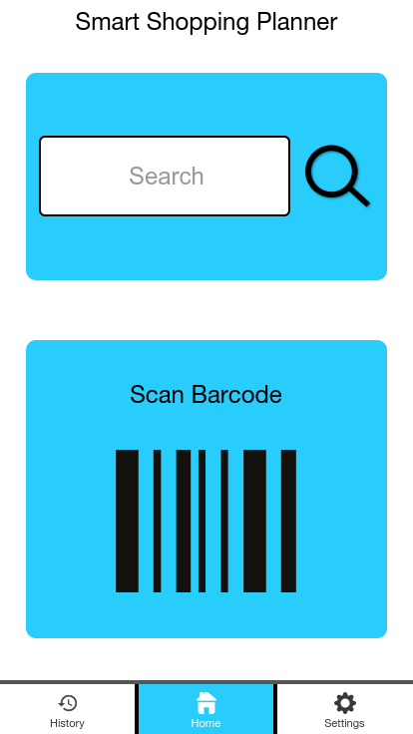

▼ Scanning Page

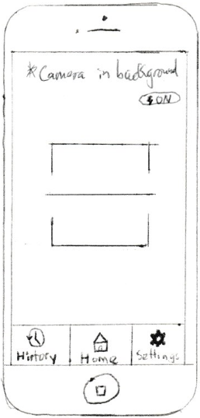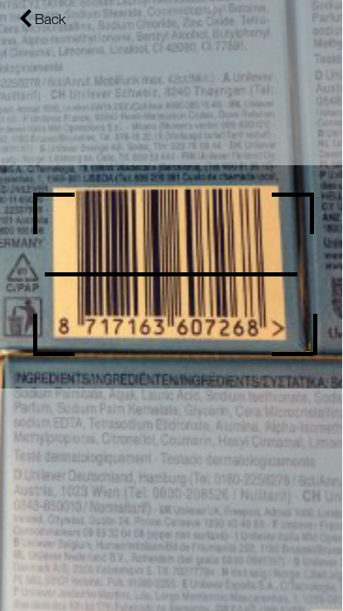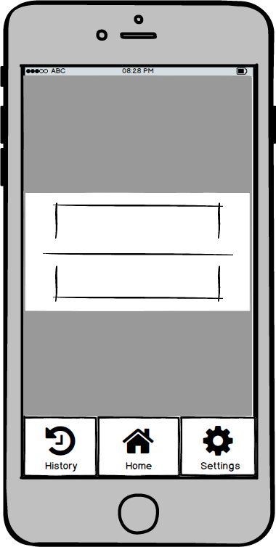

▼ Search Results

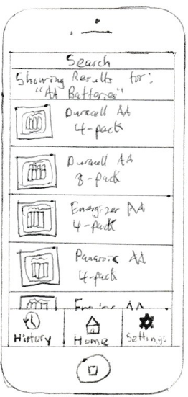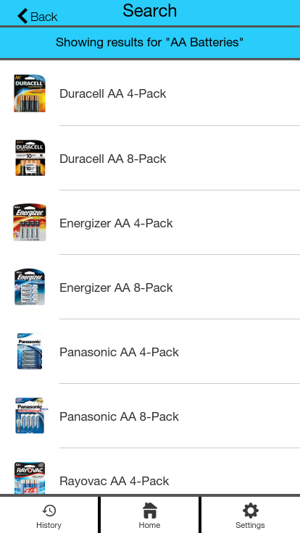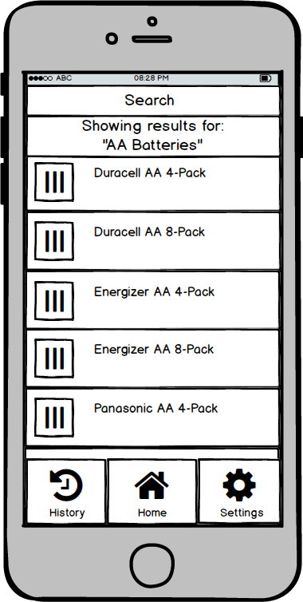

▼ Store Results

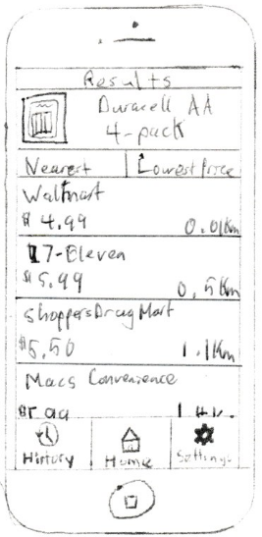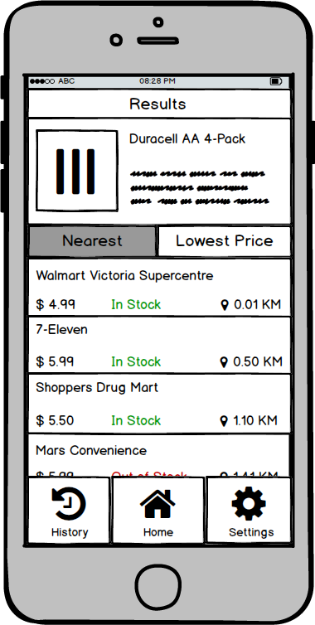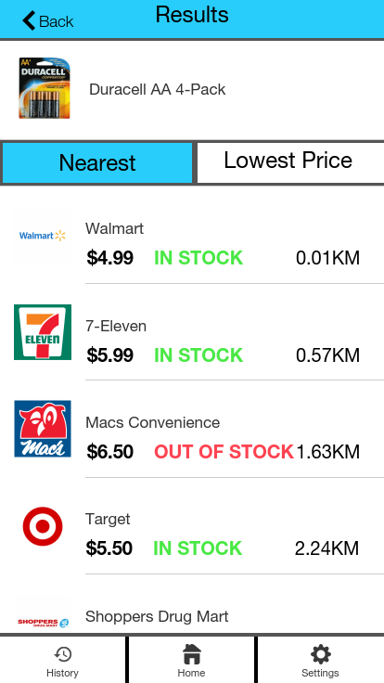

▼ Switch Ordering to Lowest

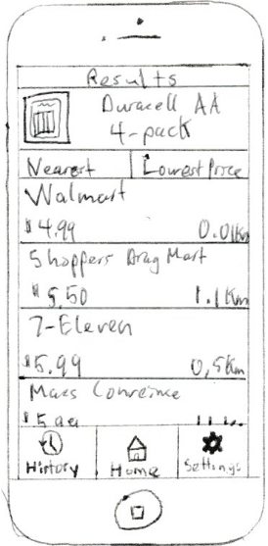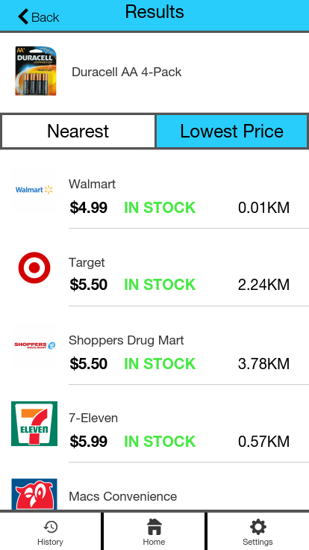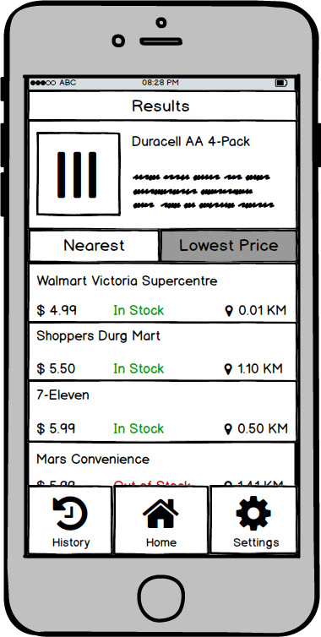

▼ Store Information

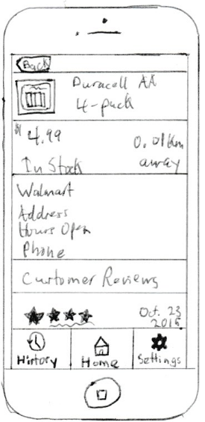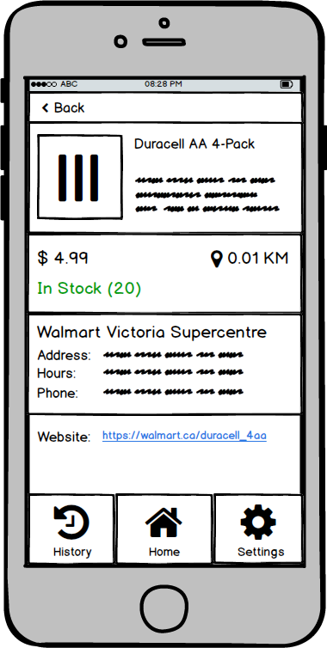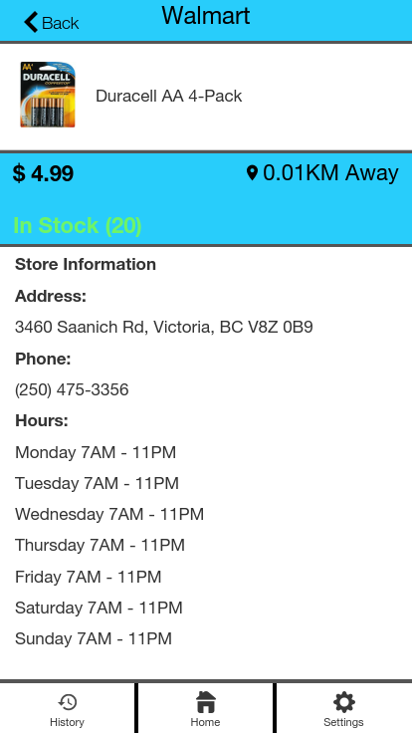

# 

# Link to the Final Prototype

The following is a link to the final version of the high fidelity prototype created with Proto.io:

<https://pr.to/Y1QTFD/>

# 

# 

# Evaluation

Our pilot evaluation was completed on July 16th. For conducting the pilot study, we all took turns running through the use cases through a preview of our prototype, alternating between facilitator and participant roles. We found that the prototype was functioning as expected, the material was mostly clear to both the evaluator and participant, and the data collection methods worked.

Our user observations were completed on July 17th and 18th. Our user observations were completed with five total users, one for each of us with someone having one extra. These users were comprised of our friends and family. The process we followed for each user observation was as follows:

1. We welcomed the user and explained the purpose of the evaluation and the user’s role
2. We informed the user that some of the options were not clickable, so they could avoid them
3. We observed the users and took notes as they performed the tasks such as quantitative data
4. We asked the users how they felt about the experience and about any troubles they had
5. We thanked the user for their time and gave them our contact information

The quantitative data that we collected from these user observations is displayed on the following pages.

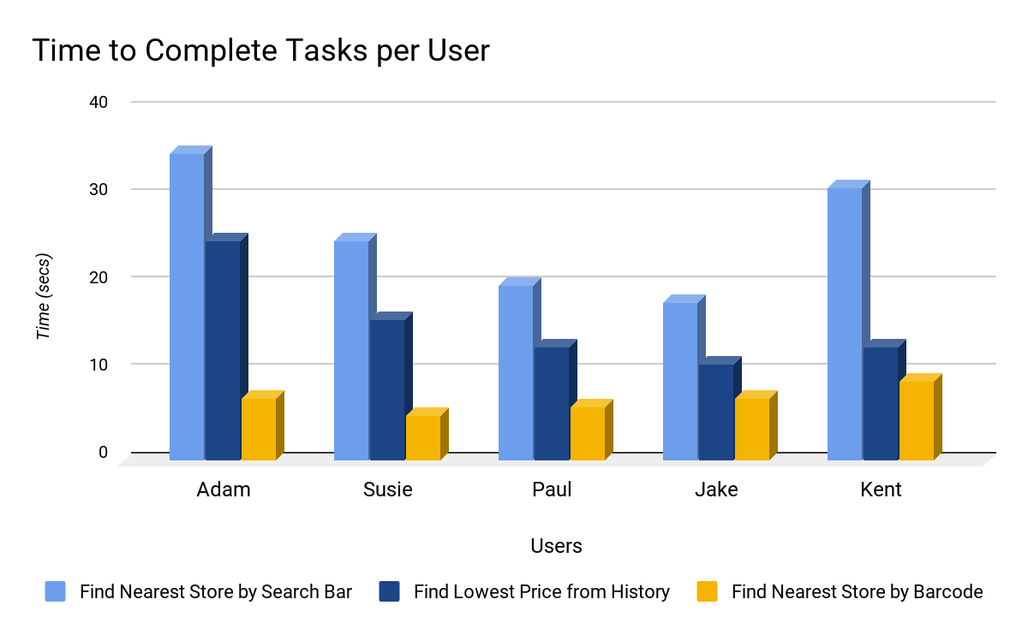

After observing users with the prototype we were able to determine that users were able to pick up on how to use the application very quickly. As the users went through the tasks they became more comfortable and familiar with the application and they were able to learn how it works since they went through the steps multiple times. We felt that our goal of efficient and learnable design had been achieved.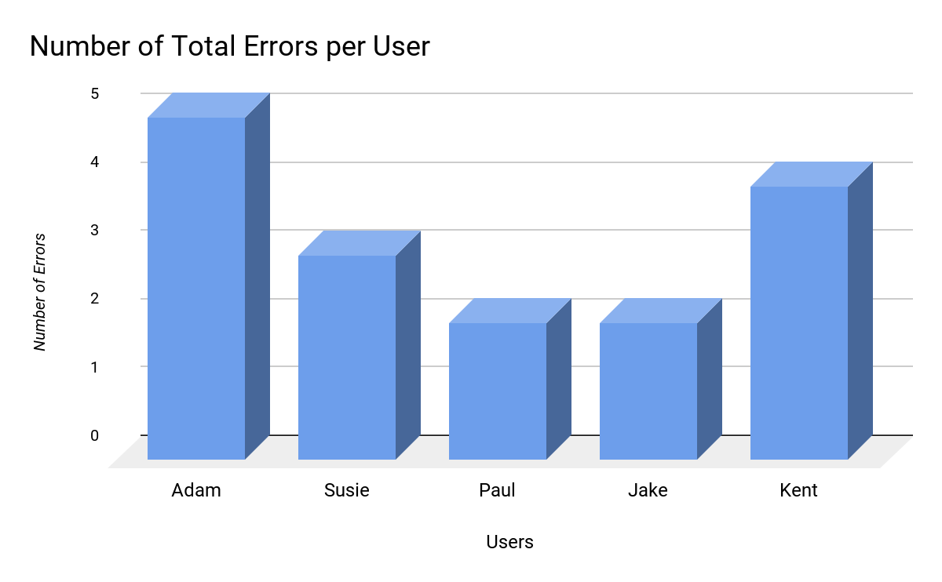

Users were able to learn from their errors and were able to overcome the problems they encountered rather quickly. Most errors occurred early on in the tasks and weren’t repeated as the users worked their way through the other tasks.

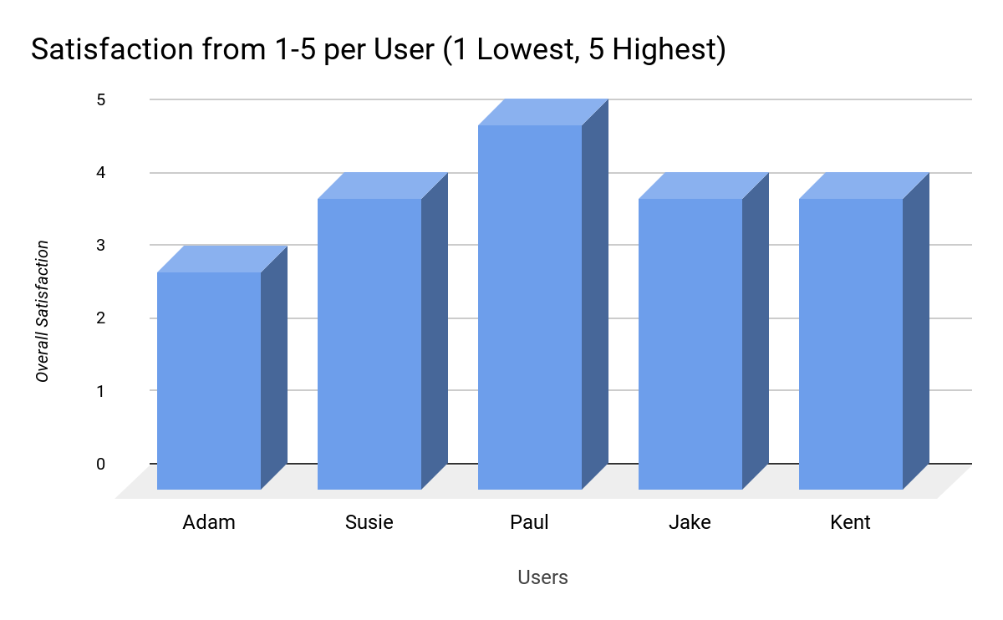

Most of the users rated the application quite highly (in the 4-5 range). We feel that this is due to users easily learning the interface and becoming more confident at every subsequent task.

Adam was the most vocal about his frustrations. He felt that it was slightly difficult to determine which elements were able to be interacted with. This was also the source of most of his errors.

Susie felt that she was able to do the tasks without any major problems and that the application worked rather well. She was marked down for three errors even though they were simply just misclicks on buttons that don’t function.

Paul and Jake felt that the tasks given were very easy and that they would have no problem doing them again after some time had passed. They were pleased with the applications ease of use.

Kent had some difficulty initially, however, he realized that he was simply over thinking the process for the first task and became much faster as he progressed.

# Updates and Changes

The main navigation bar found at the bottom of our app was changed to allow the user know where they currently are in the interface. This was done by shading the tab when the interface is on the respective screen. This change was brought on by peer evaluation and suggested by the group that reviewed our low fidelity prototype.

After realization that one of our personas did not represent an average user correctly we changed it to a more common person, a house mom. We added shading to the store results page to ensure no confusion when thinking about which ordering the list is sorted by. During testing, multiple users noted that they had to look closely to read so the font size was increased to give the user a better view of the information.

The store information page had the customer ranking and reviews in the low fidelity prototype but was decided to be removed as we felt it wasn’t something our application was meant to do and we wished to focus on the main information that we wanted to convey. The store information page also had green and red lettering to draw customers in and let them know right away if the product was in stock, so we took that further and added a number to show the quantity in stock. The website was also removed from the medium fidelity to the high fidelity prototype as we found it not to be part of the intentions of the application.

# Future Work

We found four potential improvements for this project. First is to increase the learnability by adding instructional overlays and coach marks showing on the first launch, to teach first-time users, and make new users feel comfortable and confident to use this application. Also, a Help/FAQ page will be added to the Settings page. The second improvement would be about deleting the history. The users should be able to delete their selected entries and leave the entries they want, instead of clearing the whole history at once. The third improvement would be refining the Search function by adding voice search, auto-complete, tap ahead, and recent search, in order to make searching more effective and efficient. The last possible improvement is to add a new function to compare product prices with online retailers, to provide more selections for the users.

# Lessons Learned

This section will focus on the struggles that we faced, key decisions we made, and some interesting takeaways from the project.

## Struggles Faced

We had a few challenges to deal with while working on the project. One of those challenges was coming up with two good descriptive personas and good scenarios to match them. This was difficult for us as our personas and scenarios were supposed to be two separate descriptions but they were constantly merging into each other. Our project idea is also designed with everyone in mind, so since anyone can be a persona it was hard to find a unique persona to come up with. We almost ended up being too unique as personas are supposed to fit multiple people, and our Bob persona would just not fit.

Our problems with personas and scenarios flowed into our use cases and it was difficult to fully design our use cases for our application. We also were mistaken between the actual difference from use cases and tasks. Another mistake with the use cases was assuming that the feature of scanning and searching through our design are different use cases when they are actually the same use case with a change in flow.

When trying to find time for our group to meet up and work on the project, it was difficult to actually find the time, as most of us were not able to meet. Since this was the case we tended to stay after our lab times to work on the project and get most of the requirements done with everyone present.

## Key Decisions

We had to make some important decisions with where we wanted to focus the intention of our design. An application like ours would tend to focus on savings and deals for the users. We all decided we would rather design an application that would give users access to store information such as stock quantity and availability. The stock quantity is to give the users the access to products being in stock or not along with quantity number for user options. The store availability would give users store distance and business hours. These are the features we felt that would give users the best options in determining what store and price would be the best for them.

When it came to interface features, we came to the decision to remove the customer's product rating, and customer reviews. We felt these two features were not related with the main function of the application and would just draw attention away from the real focus of the application. This was a decision that was important because it was the moment where we all knew the main idea of what we wanted to design.

## Interesting Takeaways

Designing the low, medium, and high fidelity prototypes was very interesting as it gave us insight into the user interface design process and the tools used to achieve them. The tools themselves had many objects and items that are used in standard Android and iOS, so it was cool to use them in creating our application.. Additionally, once we started using tools such as Proto.io for our high fidelity prototype, it was very easy to tie elements together and create standard layouts.

Another interesting aspect of the project was learning about tailoring your application to the correct user base via personas, scenarios, and use cases. Through the challenges we faced, we realized that certain parts of our application strayed away from our original idea, and that some of our personas did not exactly hit a unique set of relevant users. The project’s iterative design process allowed for us to constantly modify and improve these things in order to really focus on our application’s main goal and users.

Learning about the necessity of user testing was quite valuable as well. While our inspections did provide us with valuable information, user testing revealed problem points from the user’s perspective, which is something that we as designers wouldn’t be able to emulate due to our bias and attachment to the design. Using the data gained from user testing, we able able to make graphs and gain valuable insight into our application and the tasks users would be performing with it.

# Conclusion

We have made a prototype of a shopping mobile application called the Smart Shopping Planner that we feel provides the user with a useful and easy method to save time and money when shopping for products. We believe this will solve the problem of finding stock availability in store and providing the cheapest price available. Overall, our team learned many valuable lessons from this experience as it was all of our first chances at being part of a design team. Though there were struggles and stress at times, the project ended up providing us each with valuable knowledge and experience that we now get to take forward in life for future projects and designs.

# Appendix A

## Bob’s Persona

Bob, 25, lives in Vancouver, BC. Bob is a model and is very conscious about his skin. He only uses certain cosmetic brands in order to maintain his unique outlook and physical beauty. He maintains his outlook by tanning, going to the gym, and running, and the rest of his day is for his photoshoots. Since Bob encounters fans quite often, he doesn’t like shopping store to store, and would like to finish shopping as soon as possible. He would like a way to confirm whether his unique cosmetic products are in stock.

# Appendix B

## Original Scenarios

Today Bob went to Walmart to buy some Dove brand soap. He saw on the flyer of the store that the item was on sale. When he got to the store, there was an empty shelf where the product was supposed to be. There were no store associates around, but the price and barcode were on the empty shelf. Bob brought out his smartphone and used our app to scan the barcode. He found out that the store still has some in stock and the other store across town has some as well. He went to the help counter to get some assistance in finding the product. He let them know that the product is showing as in stock. The associates found the product in the back and Bob left the store with his Dove brand soap.

Today Frank went to go grab a bottle of his favorite drink, sparkling flavoured water, but he didn’t have any more. Frank was short on time, so he couldn’t check his local stores to see if the sparkling flavoured water was in stock and phoning each of the locations would also take too long. Frank used our app and his list of favorite items to check if any stores had some of the water in stock. Frank was in luck and saw that Walmart had the water on sale and in stock at a nearby location. Frank went to the store and picked up some of the sparkling flavoured water with time left to spare before his next task

# Appendix C

## Low Fidelity Prototype

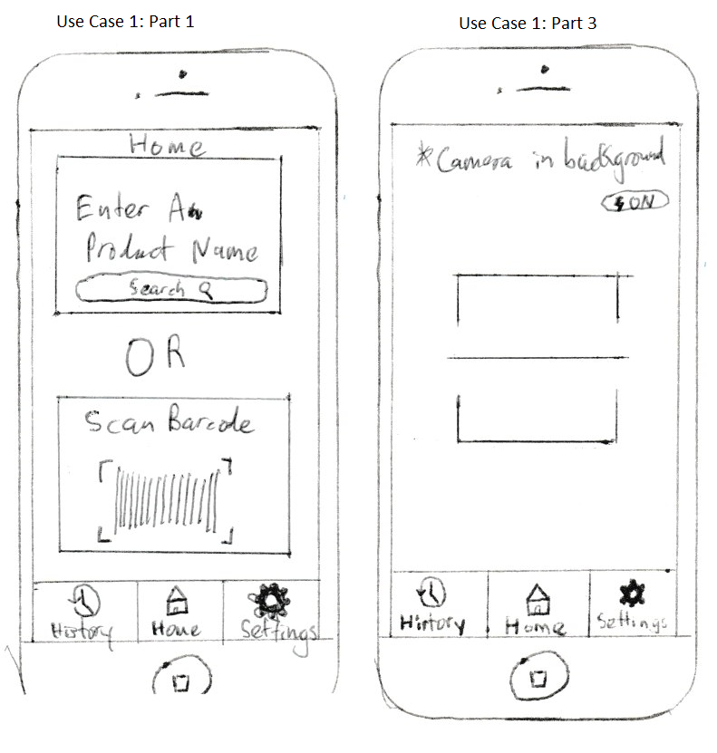

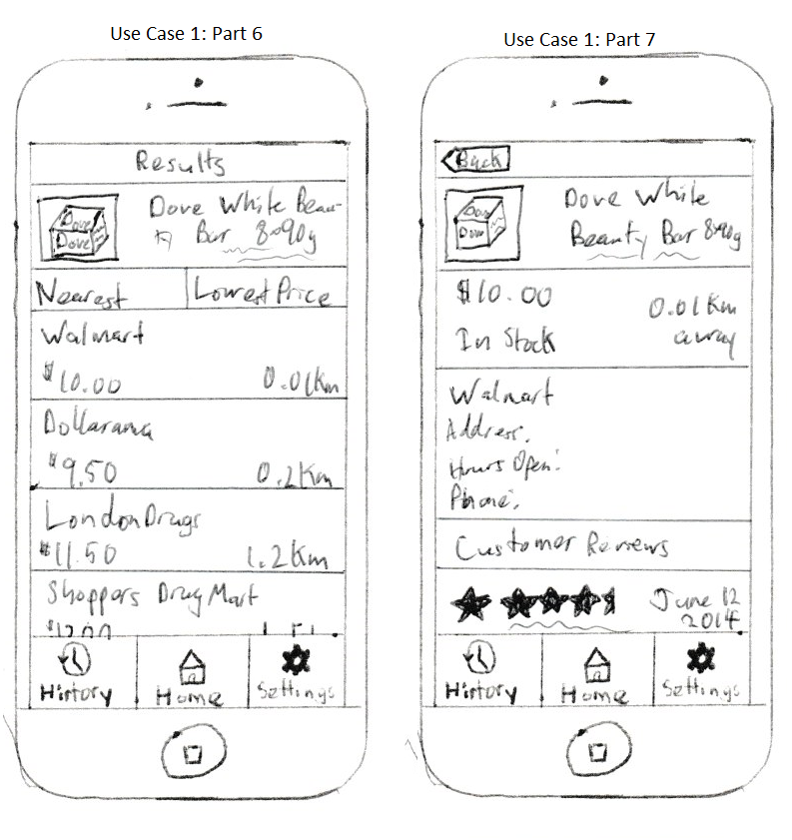

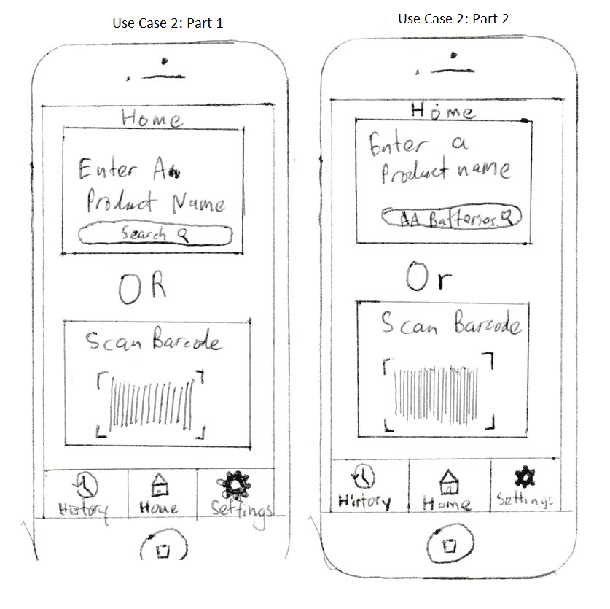

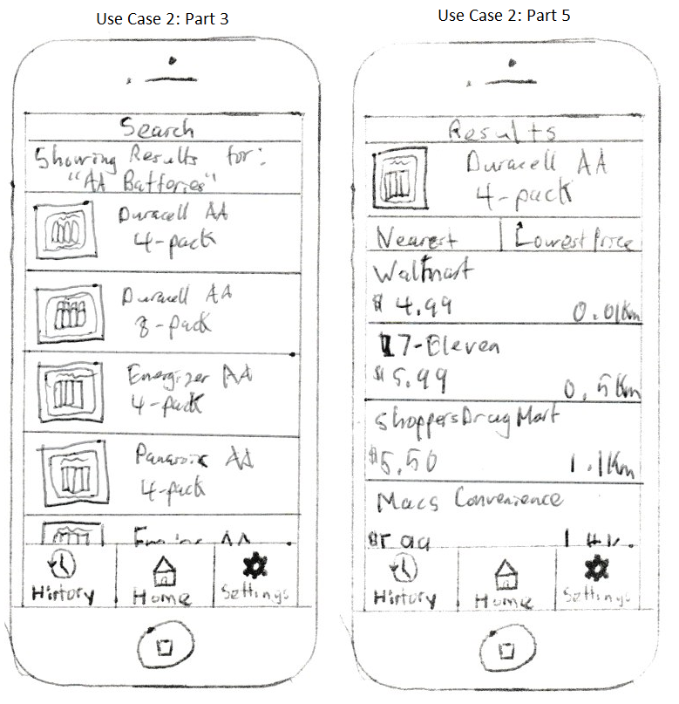

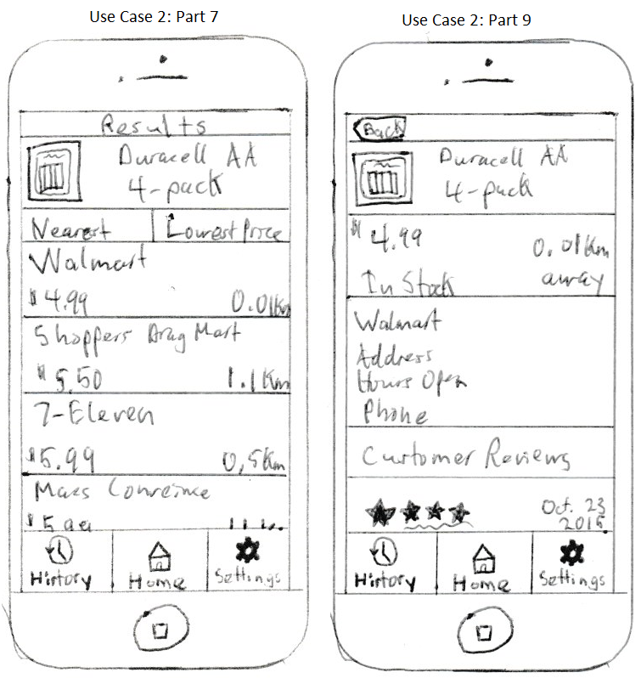

# Appendix D

## Medium Fidelity Prototype

**Home Page Scanning Page**



**History Page (0 results) History Page (2 results)**

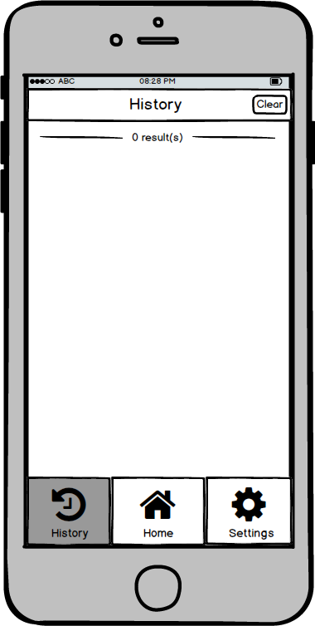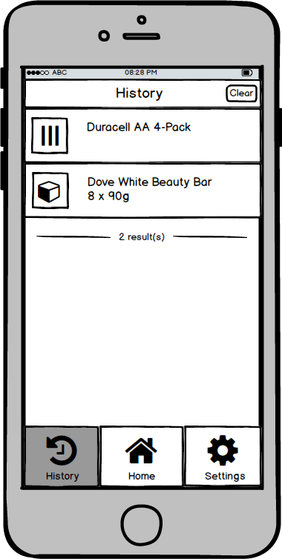

**Search Page (AA Batteries) Search Results**

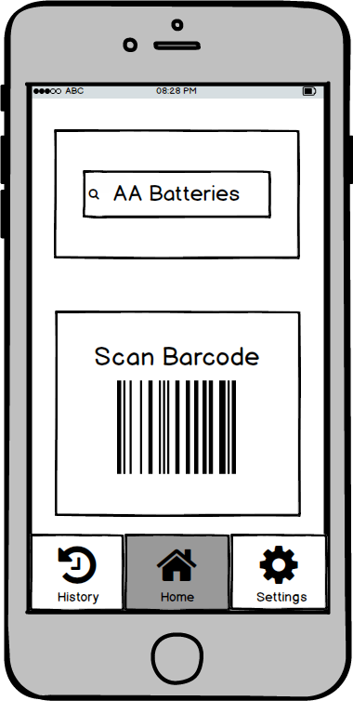

**Product Page (lowest price) Product Page (nearest)**



**Store Information Page Settings**

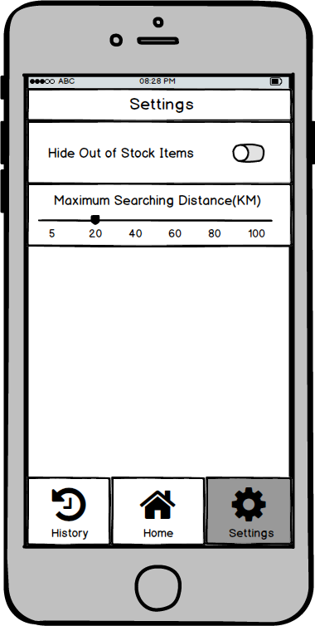

**Store Information Page (dove soap) Product Page (dove soap)**

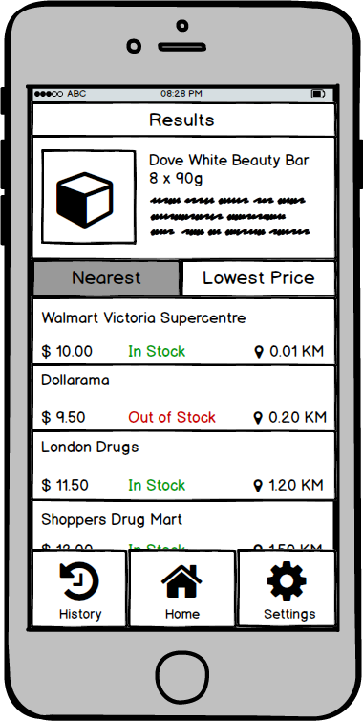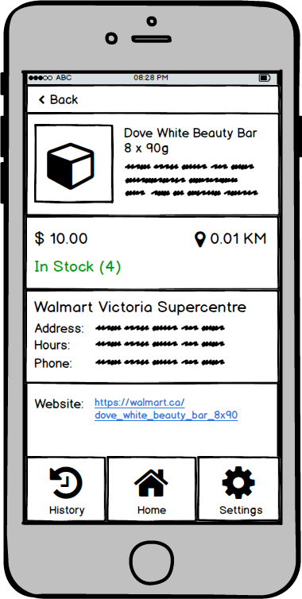

# Appendix E

## Survey Results

